Laptop Request Management System
Project Documentation
ServiceNow Application

1. Introduction
Project Title: Laptop Request Management System
Team Member: Guraka Murali
The Laptop Request Management System is a ServiceNow-based application designed to digitize and automate the process of requesting, approving, processing, and tracking laptop requirements for employees.

2. Project Overview
Purpose: To provide a centralized and transparent process for employees to submit laptop requests and for managers and IT teams to review, approve, process, and track those requests.
Key Features:
- Laptop request form for employee requests.
- Requester, employee email, laptop type, reason, manager, date, and status information.
- Manager approval and rejection workflow.
- Automated workflow using ServiceNow Flow Designer.
- Business Rule to prevent duplicate laptop requests for the same user within the current calendar year.
- Role-based access using IT Employee and IT Manager roles.
- ACL-based control for create, read, and write access.
- Approval records and request status tracking.
- Email/flow notifications related to approval processing.

3. Architecture
The application is implemented within the ServiceNow platform. Employees interact with the request form/catalog interface, while ServiceNow tables store request information. Business Rules perform validation, Flow Designer manages approval and workflow actions, and ACLs and roles provide access control.
User Interface: ServiceNow Laptop Request Form and Employee Service Catalog/Record Producer.
Application Layer: ServiceNow application logic, Business Rules, Flow Designer, and approval processing.
Data Layer: Laptop Request Form table containing request, employee, laptop, status, and manager information.
Security Layer: IT Employee and IT Manager roles with ACLs controlling access to records and operations
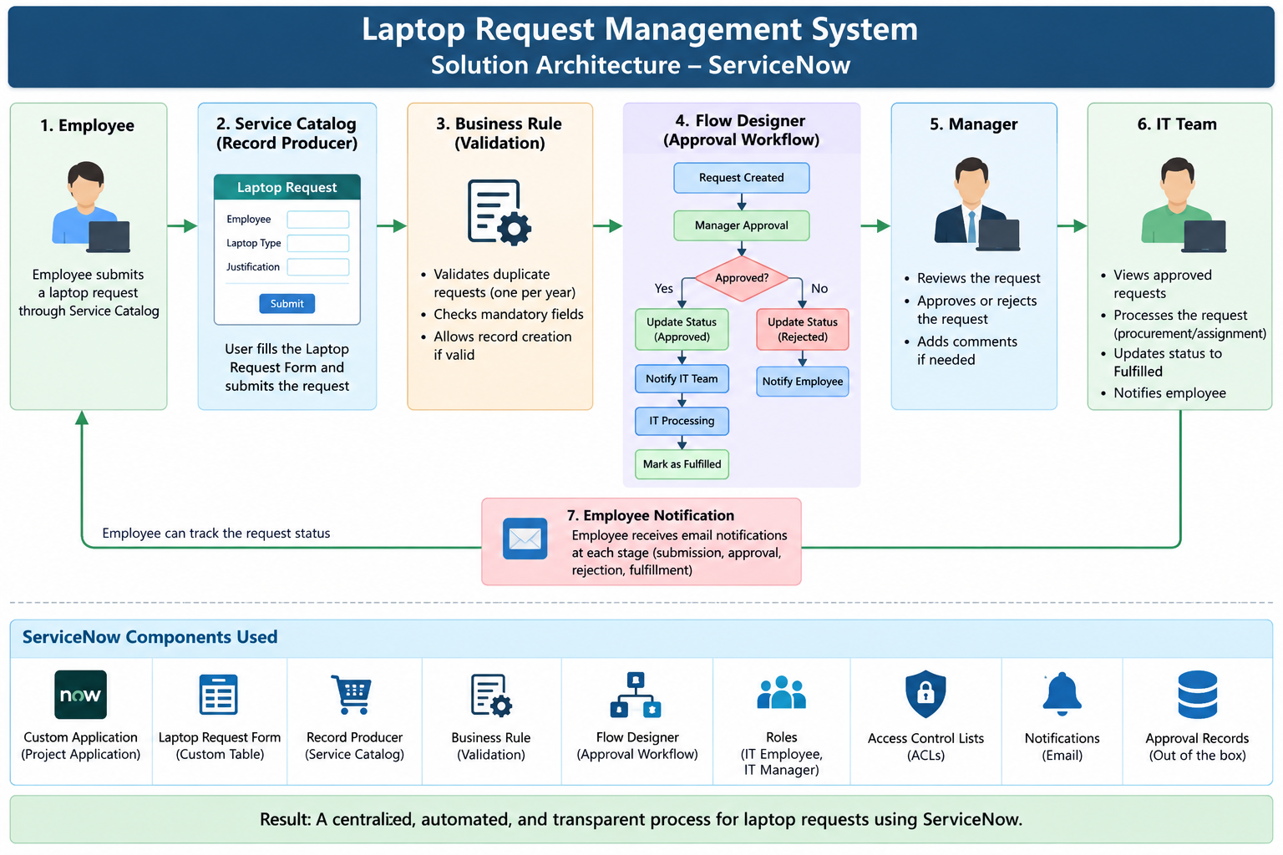
Figure 1: Solution Architecture Diagram – Laptop Request Management System

4. Setup Instructions
The application is configured and executed in a ServiceNow instance. The following requirements are needed to access and use the project:
- A valid ServiceNow instance and user account.
- Appropriate ServiceNow roles/permissions for the required activities.
- Access to the custom Laptop Request Management application.
- Access to the Laptop Request Form, Record Producer, workflow, and related records.
Security Note: User credentials and passwords are not included in this document.

5. Folder Structure
The project documentation is organized by project phase. The documentation package contains project planning, design, development/testing, and final documentation material.
- Project Planning – backlog, tracker, velocity, planning logic, and burndown chart.
- Project Design – solution architecture, proposed solution, and problem–solution fit.
- Project Development – User Acceptance Testing and Performance Testing.
- Project Documentation – FSD documentation and final report.
Project documentation folder structure:
Project Documentation/
├── FSD Documentation
└── Final Report
Project Development Phase/
├── User Acceptance Testing/
└── Performance Testing/

6. Running the Application
The application is accessed through the organization's ServiceNow instance. After logging in with an authorized account, the user can open the Laptop Request Management application and submit or process requests according to their assigned role.
- Log in to the authorized ServiceNow instance.
- Open the Laptop Request Management application.
- For an employee request, open the Laptop Request Form/Record Producer.
- Enter the required employee and laptop information and submit the request.
- The configured validation checks the request and prevents duplicate requests when applicable.
- The approval workflow routes the request for manager approval.
- The manager approves or rejects the request.
- IT users process approved requests and update the request status as required.
- Users can review request and approval information from the relevant ServiceNow records.
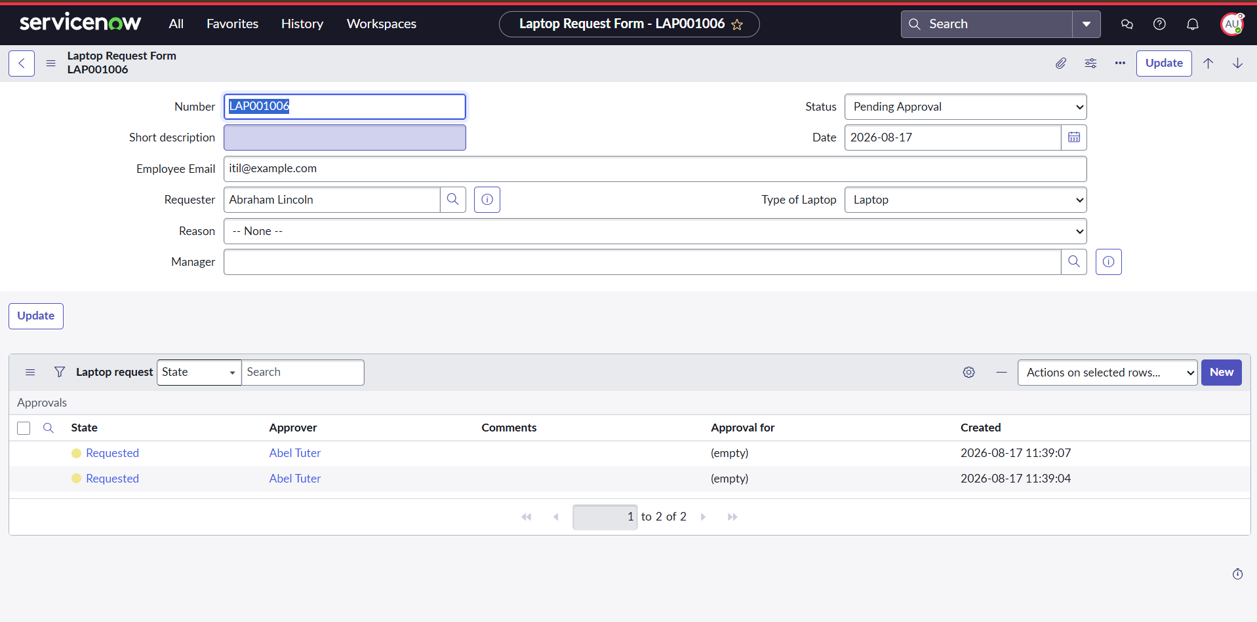
Figure 2: Laptop Request Submission Screen

7. API Documentation
Not Applicable. The current version of the Laptop Request Management System does not implement a separate custom REST API or external backend API. The application uses ServiceNow's platform capabilities, tables, Business Rules, Flow Designer, approvals, roles, and ACLs.

8. Authentication
Access to the application is controlled through the ServiceNow platform's user accounts and role-based authorization. Different project roles are used to control the operations available to employees and IT managers.
IT Employee Role: Provides authorized IT employee access to relevant laptop request operations.
IT Manager Role: Provides manager-level access required for reviewing and approving requests.
ACLs: Create, read, and write access is controlled using configured Access Control Lists.
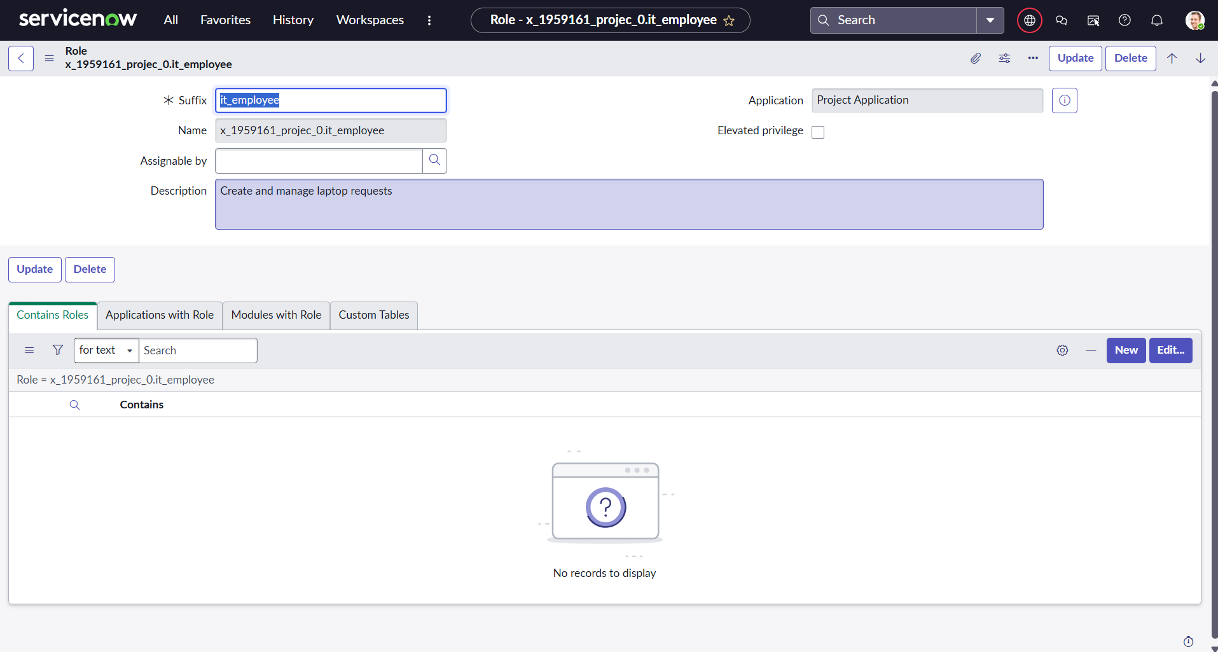
Figure 3: IT Employee Role Configuration
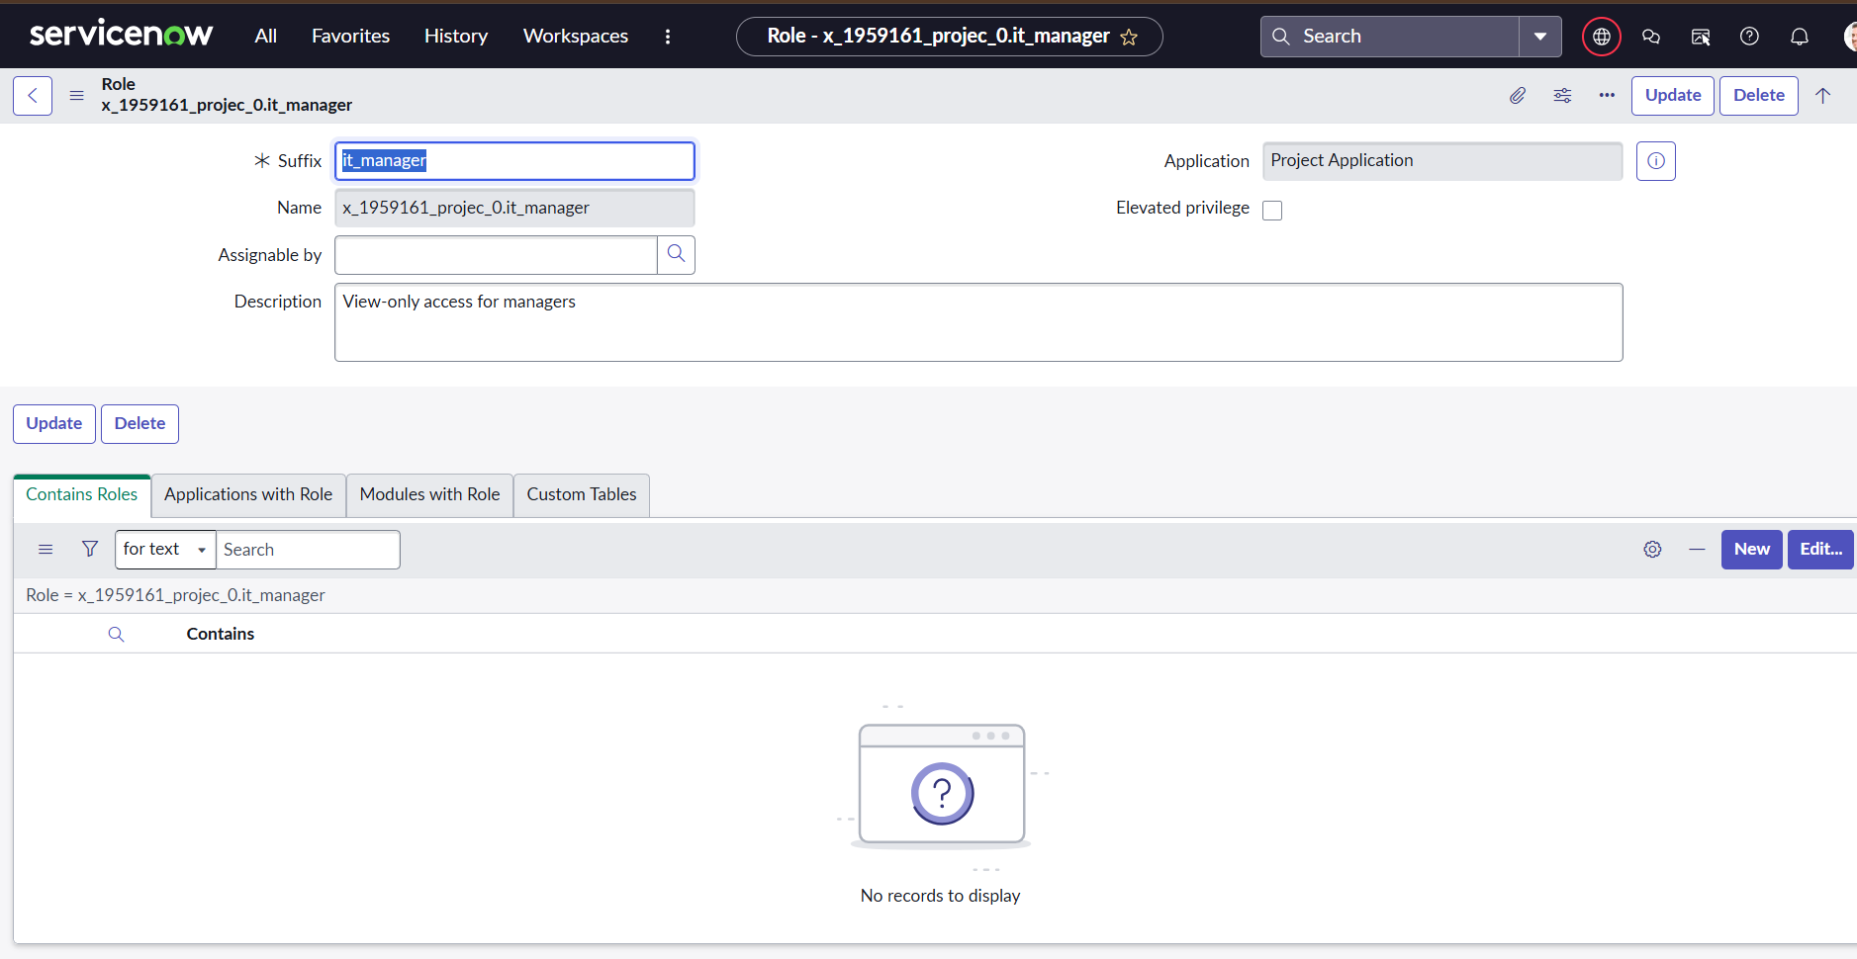
Figure 4: IT Manager Role Configuration
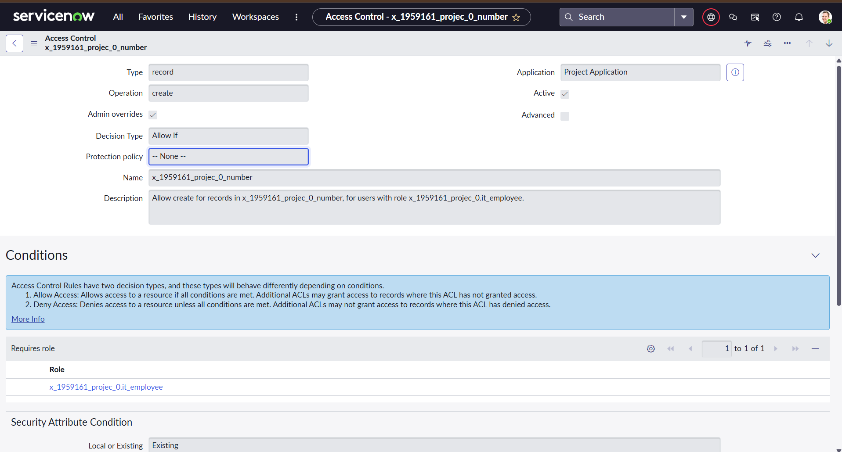
Figure 5: ACL Configuration for Create Access
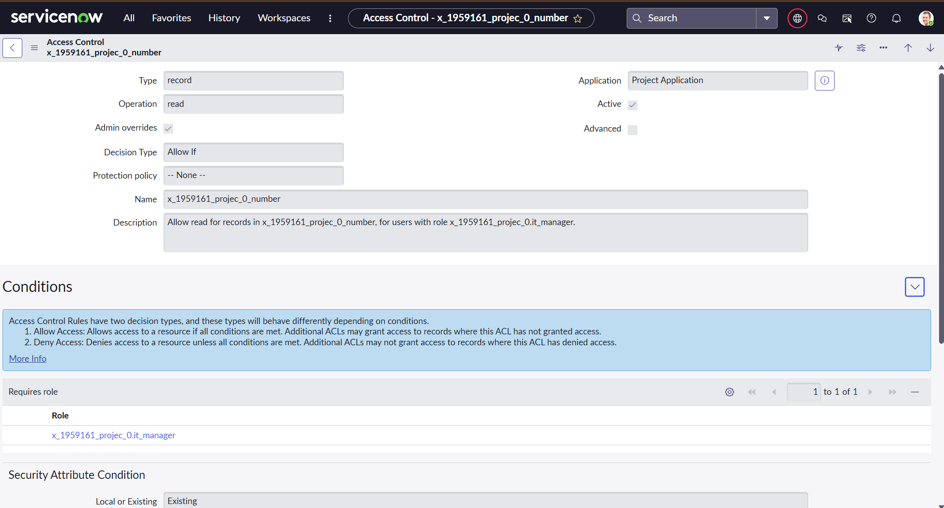
Figure 6: ACL Configuration for Read Access

9. User Interface
The user interface is provided through ServiceNow forms, lists, and catalog/request components. The main Laptop Request Form captures the information needed to process a request.
- Laptop Request Form
- Employee Service Catalog / Record Producer
- Laptop request list and individual request records
- Approval related list
- Manager approval interface
- Request status and tracking information
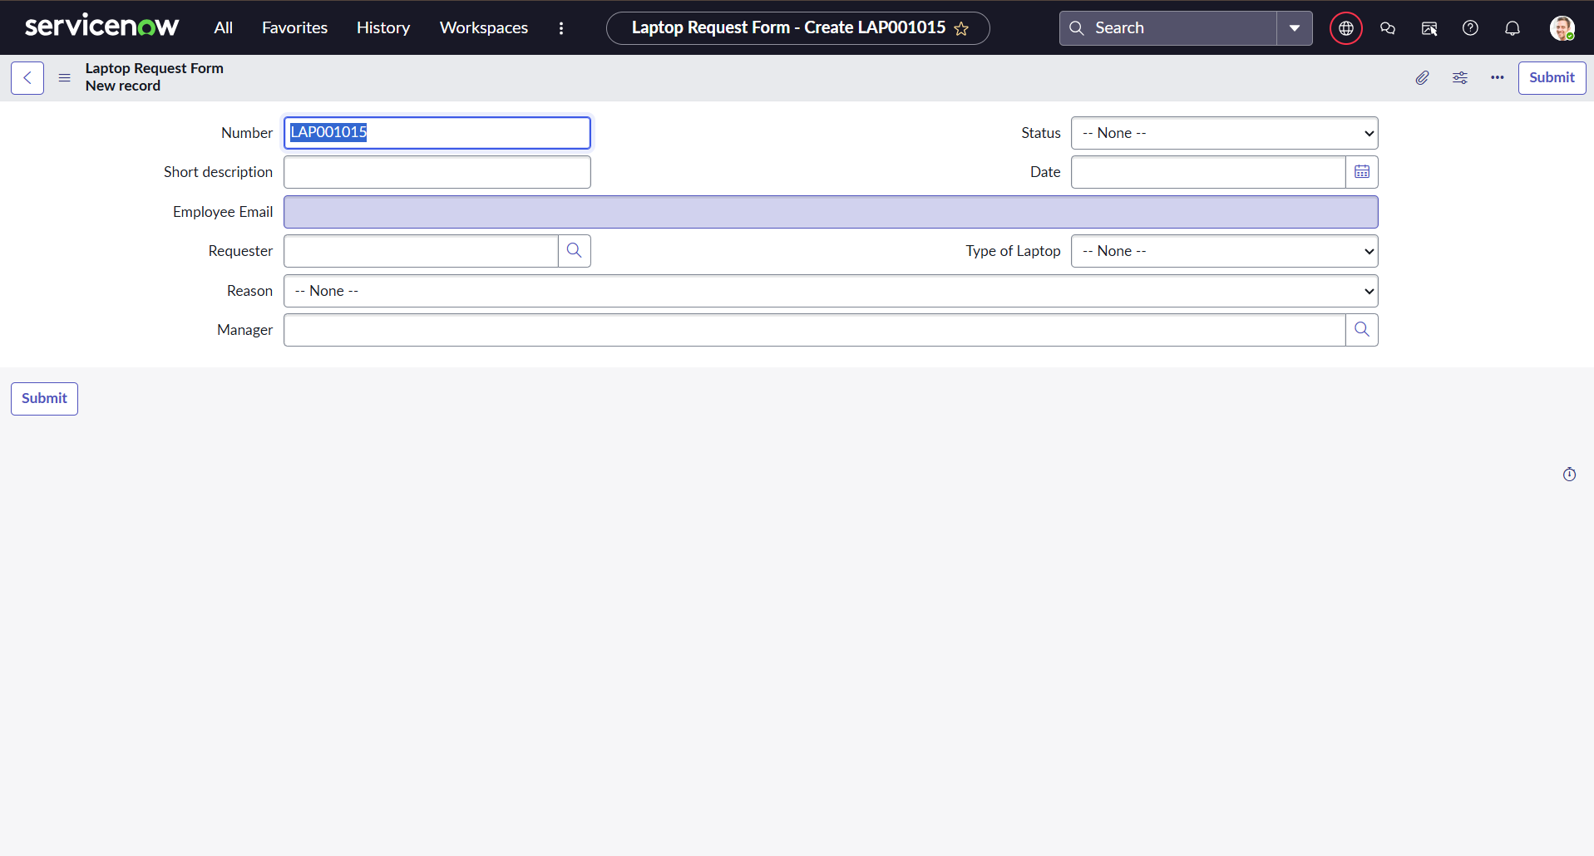
Figure 7: Laptop Request Form
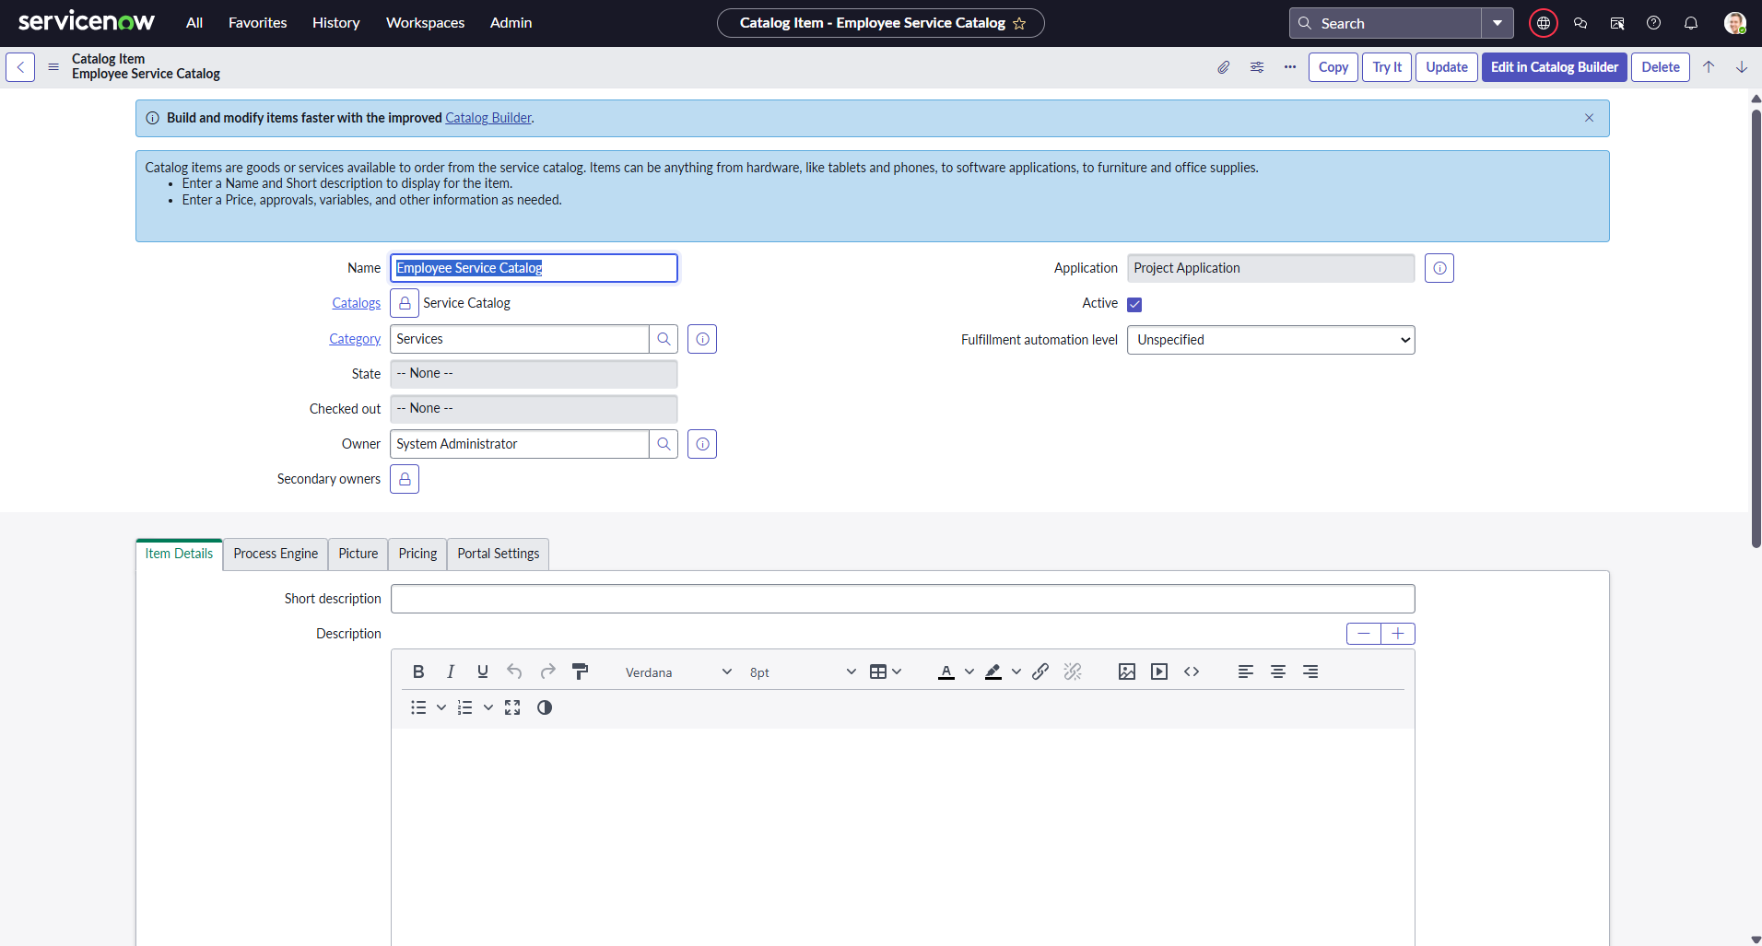
Figure 8: Employee Service Catalog
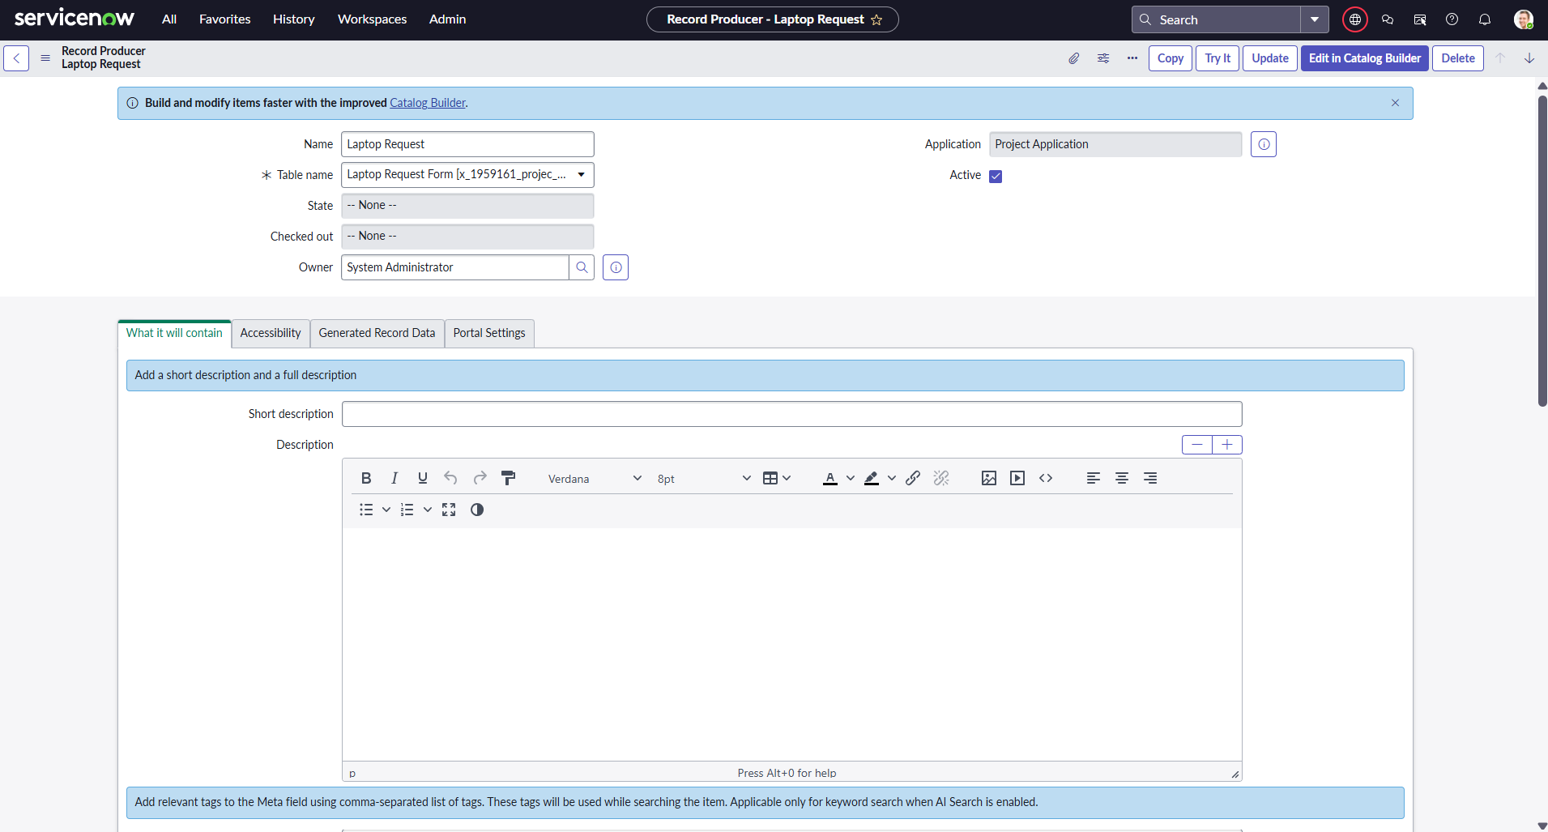
Figure 9: Laptop Request Record Producer
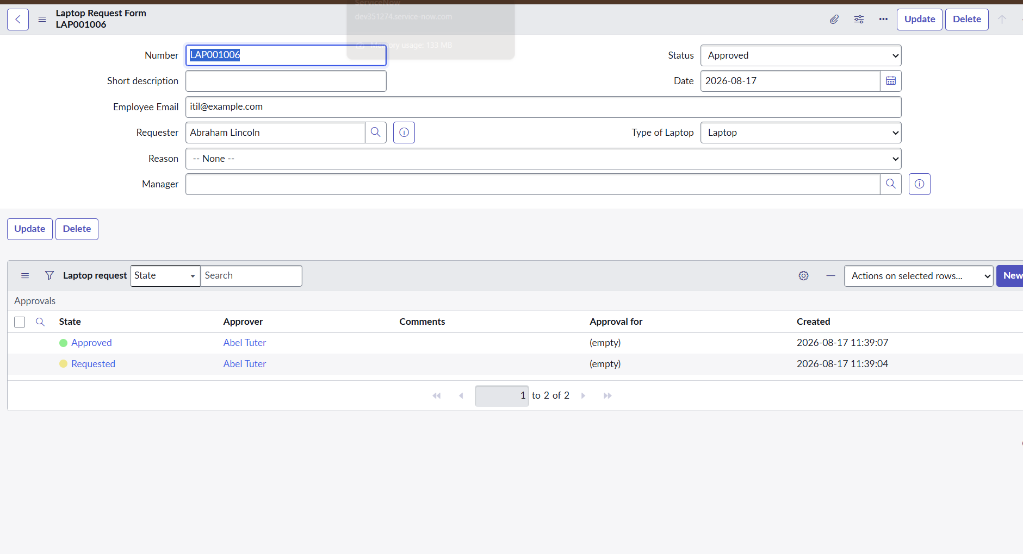
Figure 10: Laptop Request Record with Approval Records

10. Testing
Testing was performed to verify the main functional workflow and project behavior. The project documentation includes User Acceptance Testing and System Performance Testing.
User Acceptance Testing: Covers request submission, manager approval/rejection, notifications, IT processing, laptop assignment, request tracking, and duplicate request validation.
Performance Testing: Reviews request data, data validation, record filtering, and the availability of dashboard/report functionality.
Security Testing: Role and ACL configuration was reviewed for controlled access to request operations.
UAT Result Summary: 8 project-specific UAT test cases are documented in the UAT report. The final Pass/Fail/Not Tested values should reflect the actual executed tests.

11. Screenshots or Demo
Screenshots and a project demonstration can be used to showcase the main ServiceNow features and workflow. Recommended screenshots include:
- Project application overview.
- Laptop Request Form.
- Record Producer – Laptop Request.
- Business Rule for duplicate request validation.
- Duplicate request validation result.
- Flow Designer approval workflow.
- Approval record / manager approval.
- IT Employee and IT Manager roles.
- ACL configuration.
- Laptop request record and approval related list.
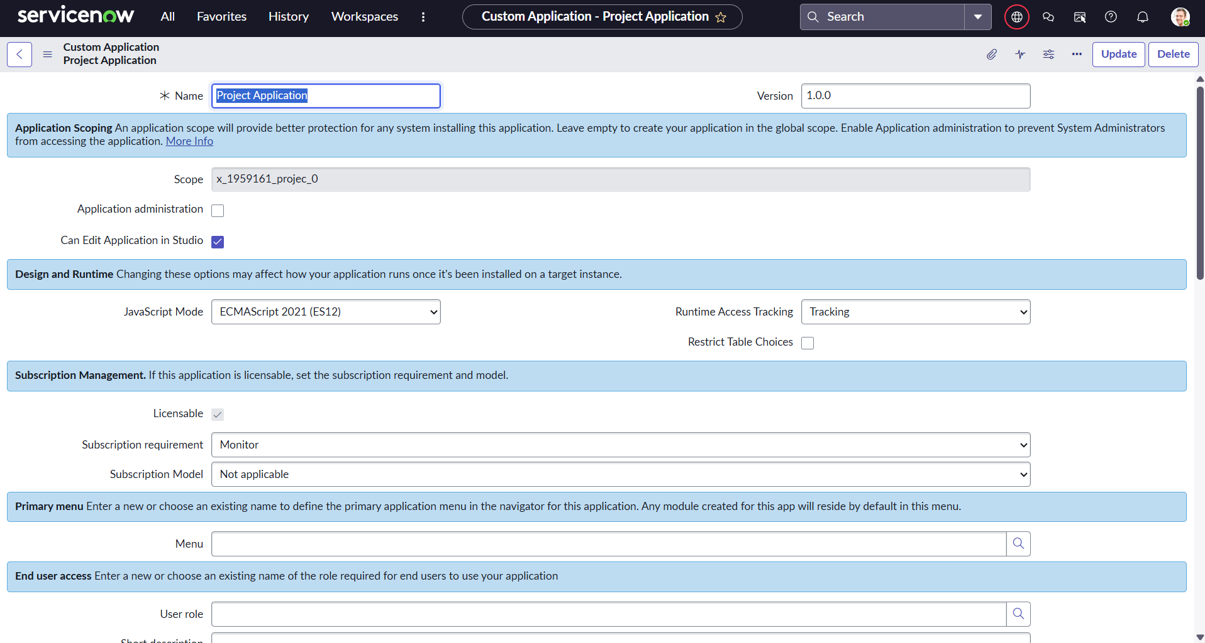
Figure 11: ServiceNow Project Application
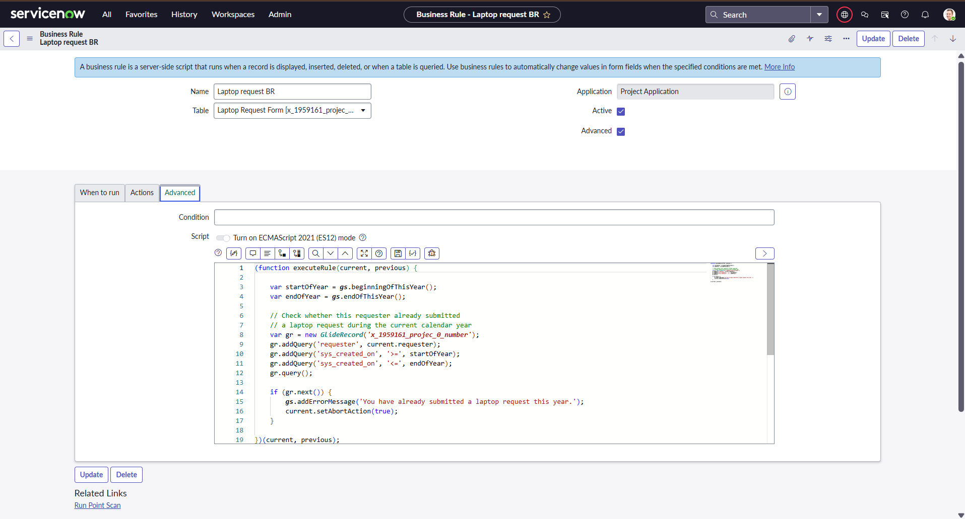
Figure 12: Business Rule for Duplicate Request Validation
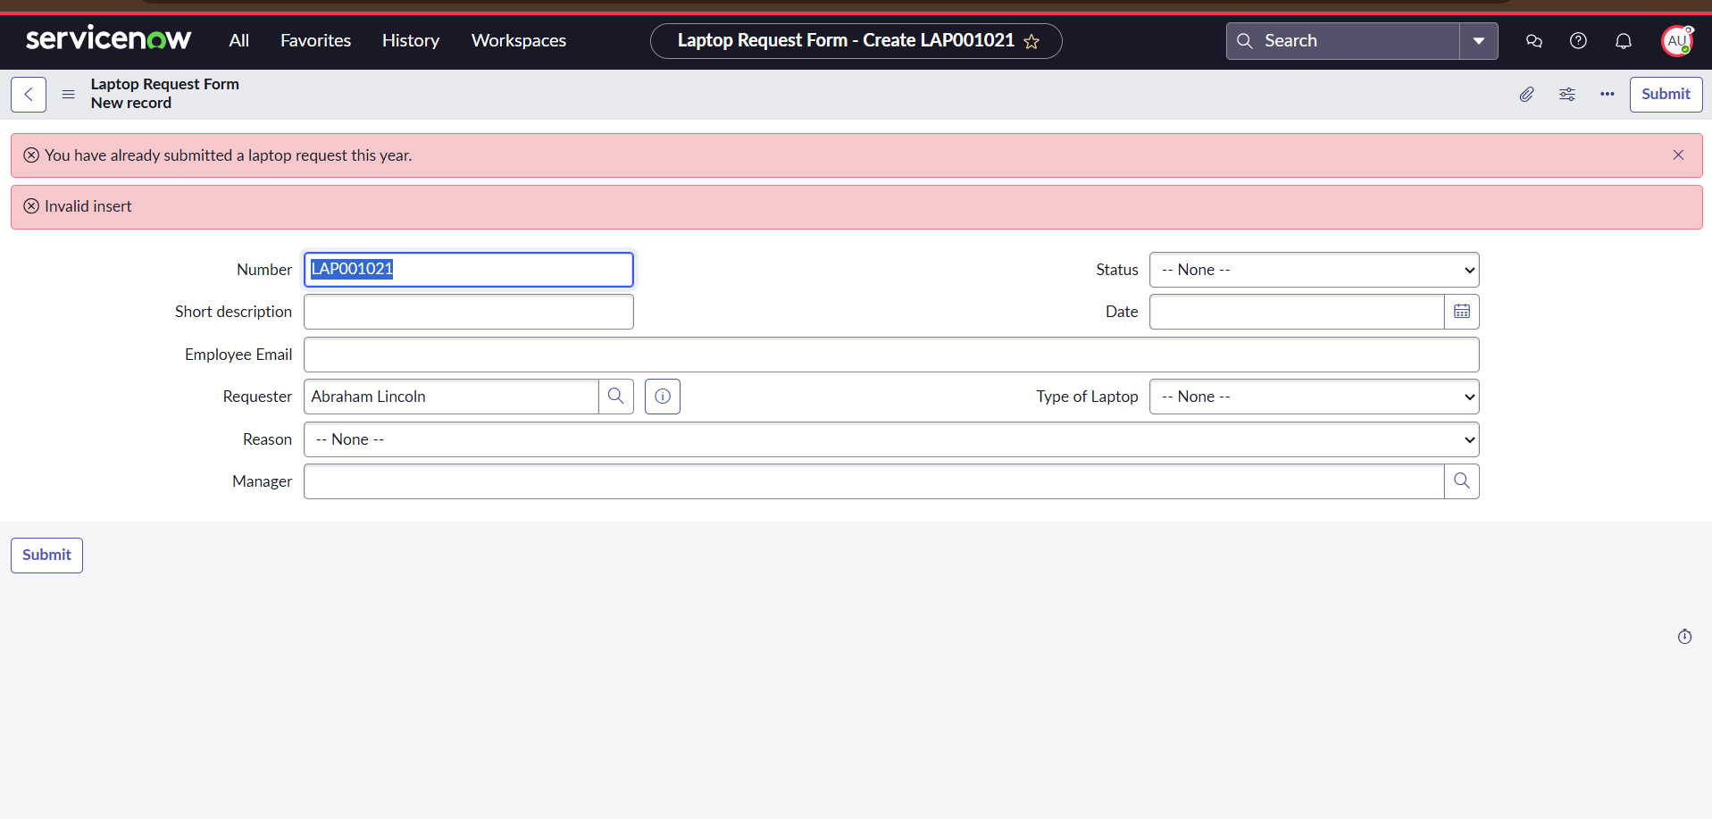
Figure 13: Duplicate Laptop Request Validation Result
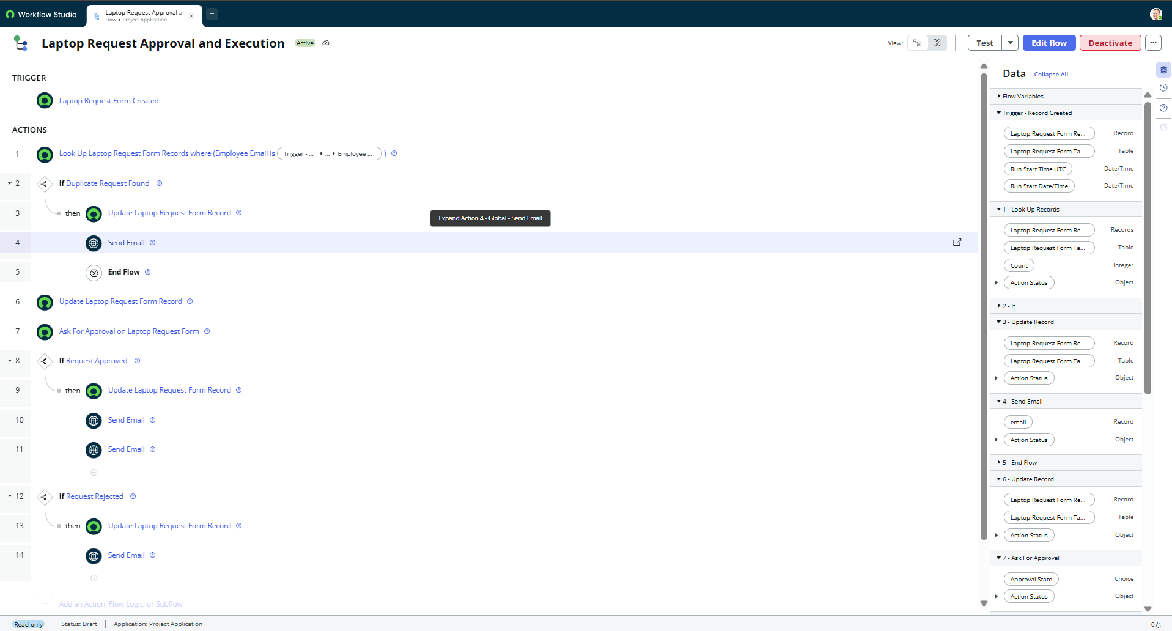
Figure 14: Laptop Request Approval and Execution Flow
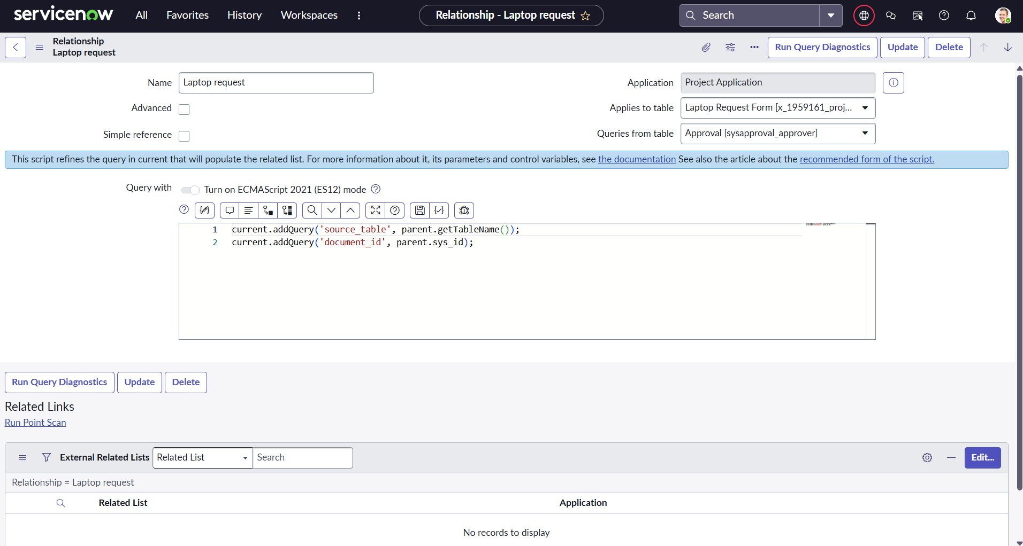
Figure 15: Approval Relationship Configuration
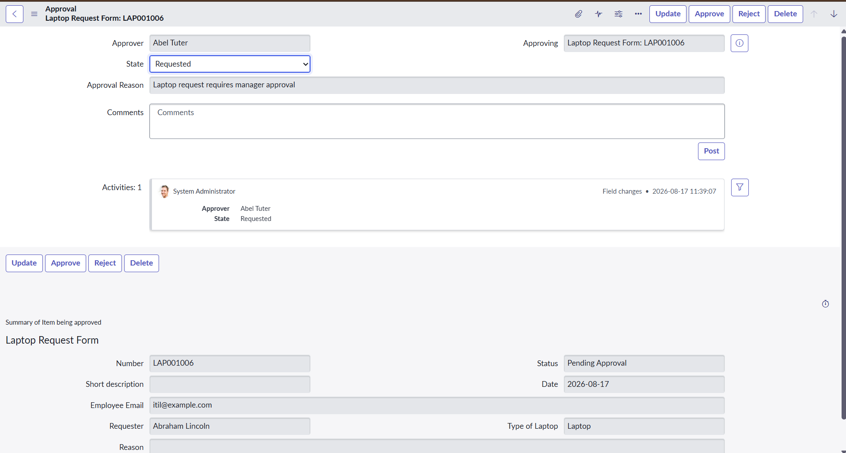
Figure 16: Manager Approval Request
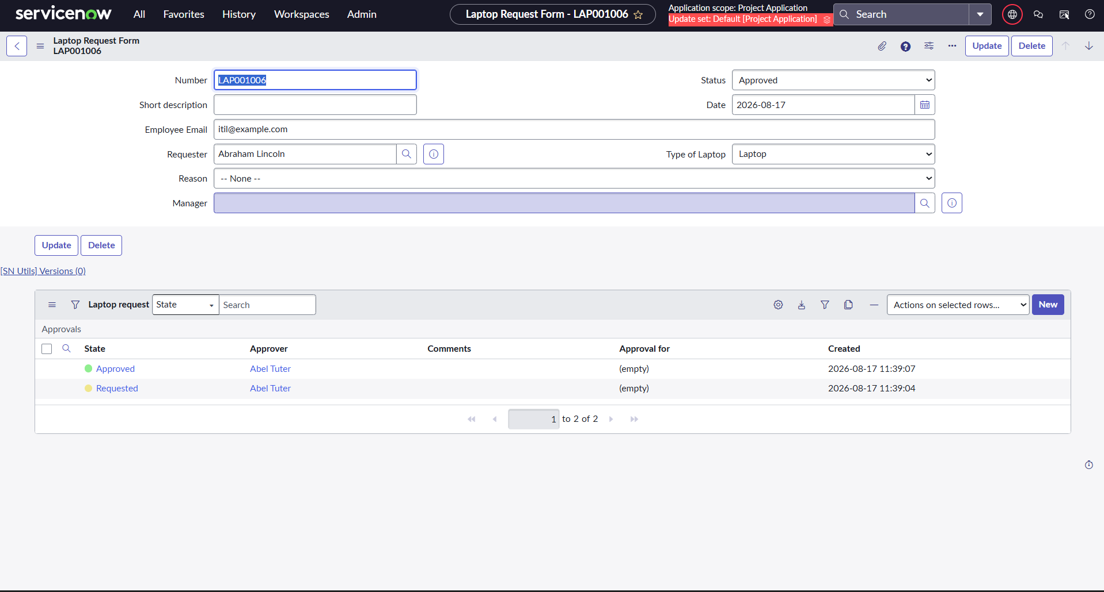
Figure 17: Laptop Request with Approved Status
Demo Video: Insert the final project demonstration video link here after uploading the video.

12. Known Issues
The current version does not include a separate dashboard or story/report visualization. It also does not implement a separate custom API layer. These are documented as Not Applicable in the Performance Testing document rather than being treated as defects.
Any additional issue discovered after final testing should be added here with its description, impact, and status.

13. Future Enhancements
- Add a dedicated dashboard showing request, approval, and fulfillment statistics.
- Add reports for pending, approved, rejected, and completed requests.
- Extend the system to support additional equipment such as monitors, keyboards, and mobile devices.
- Integrate laptop inventory/asset information for automatic availability checks.
- Add more advanced notifications and reminders for pending approvals.
- Add additional approval rules based on department, location, laptop type, or cost.
- Provide enhanced request analytics and management views.

Conclusion
The Laptop Request Management System provides a structured ServiceNow-based solution for managing employee laptop requests. It combines request submission, validation, manager approval, role-based security, workflow automation, notifications, and request tracking within a centralized platform. The documentation can be extended with final screenshots and the project demonstration link.

References
- ServiceNow platform documentation and product guidance.
- ServiceNow Flow Designer documentation.
- ServiceNow Access Control List (ACL) documentation.
- Project-specific User Acceptance Testing document.
- Project-specific Performance Testing document.

